Epsom & Ewell F.C.
19
v
Guildford City
Tuesday, 17th January 2017 – 7.45 p.m.
Good evening! We welcome back the players, supporters and officials of Guildford City, today’s officials and of course, our own regular faces for tonight’s League match.

We apologise for the smaller than usual programme today. Some of the information would have been very similar to last week’s and we have a larger issue coming up on Saturday.

It is only seven days since our opponents made the journey, when we lost 2-1. We pushed well at the start and also at the end, but the hour in the middle wasn’t our finest and we had to admit defeat.

Since then we visited Hanworth Villa on Saturday, where we did almost all of the work but conceded early and just weren’t able to turn the match around, losing 1-0.

Our next match is on Saturday when we host Bedfont & Feltham in a League match. No Epsom supporters will need reminding of what happened back in our opening match of the season on 2nd August, although things have changed there now with the replacement of their Manager, former Epsom player John Cook. They remain bottom of the table but will present at tougher proposition this time out.

Following that, on Tuesday 24th January we journey to The Orchard, of course, home of Bedfont & Feltham for a League match with CB Hounslow United who currently ground share at the venue. They are close to moving in to a very nice looking new ground next season at Green Lane and they will be a side to watch next season. For us a measure of revenge would be nice as they hammered us 5-1 here in August. This match remains, as I write, our only home league defeat of the season.

We then have a further two away matches, firstly at AFC Hayes on Saturday 28th January and then three days after that we travel to Walton & Hersham for the Quarter-Final of our League Cup tie at Stompond Lane, before returning here on Saturday 4th February for a League match against Badshot Lea.

We are also still looking for match and player sponsors, so if you would like to help us, please speak to any Committee Member and we can arrange this for you. The cost of a sponsorship is £55 while player sponsorship is £40.

Finally Charlie Clark-Gleave has announced his retirement from the game after suffering a further back injury. We would like to thank him for his efforts and hope he recovers quickly.

Enjoy the game!

Rich

You can follow us on Facebook: www.facebook.com/epsomandewellfc
Twitter: @EEFCOfficial Instagram at: www.instagram.com/epsomandewellfc
and on Youtube at: www.youtube.com/channel/UCtLrpS0x5OaYUACRT34_zng

Cover photos by Gemma Jarman

- Rob Hendry puts us 2-1 up against Spelthorne Sports in our last home league match

- Hendry congratulates Matt Ferdinando after his 25 yarder puts us 3-1 up in the same match

Cherry Red Records Combined Counties League
Premier Division Table 2016/17
incl Saturday 14th January | P | W | D | L | F | A | Pts | GD | H | A
Hartley Wintney | 29 | 24 | 3 | 2 | 95 | 28 | 75 | +67 | 18/3 | 1-3
Westfield | 27 | 17 | 6 | 4 | 62 | 31 | 57 | +31 | 18/2 | 1-2
Hanworth Villa | 30 | 17 | 5 | 8 | 51 | 33 | 56 | +18 | 2-2 | 0-1
Walton & Hersham | 26 | 13 | 10 | 3 | 44 | 25 | 49 | +19 | 4/3 | 1-1
Horley Town | 26 | 14 | 5 | 7 | 61 | 39 | 47 | +22 | 3-0 | 17/4
Camberley Town | 27 | 14 | 4 | 9 | 56 | 32 | 46 | +24 | 0-0 | 1/4
Knaphill | 27 | 14 | 3 | 10 | 56 | 50 | 45 | +6 | 4-0 | 8/4
Epsom & Ewell | 26 | 12 | 7 | 7 | 58 | 38 | 43 | +20 | X | X
Windsor | 29 | 11 | 6 | 12 | 55 | 50 | 39 | +5 | 2-0 | 1-2
Guildford City | 30 | 11 | 6 | 13 | 61 | 64 | 39 | -3 | 17/1 | 2-0
Abbey Rangers | 28 | 11 | 5 | 12 | 47 | 52 | 38 | -5 | 7-1 | 20/2
Bedfont Sports | 26 | 11 | 5 | 10 | 45 | 50 | 38 | -5 | 5-1 | 7/2
North Greenford United | 25 | 10 | 4 | 11 | 51 | 47 | 34 | +4 | 22/4 | 1-2
Colliers Wood United | 25 | 9 | 7 | 9 | 42 | 42 | 34 | 0 | 14/4 | 0-5
AFC Hayes | 28 | 9 | 6 | 13 | 46 | 54 | 33 | -8 | 2-2 | 28/1
Spelthorne Sports | 27 | 9 | 5 | 13 | 45 | 52 | 32 | -7 | 3-2 | 25/2
CB Hounslow United | 26 | 9 | 3 | 14 | 41 | 56 | 30 | -15 | 1-5 | 24/1
Farnham Town | 26 | 9 | 3 | 14 | 39 | 55 | 30 | -16 | 25/3 | 2-1
Chertsey Town | 27 | 7 | 6 | 14 | 36 | 64 | 27 | -28 | 2-1 | 11/2
Sutton Common Rovers | 23 | 7 | 4 | 12 | 30 | 42 | 25 | -12 | 2-1 | 1-1
Raynes Park Vale | 28 | 4 | 7 | 17 | 34 | 61 | 19 | -27 | 1-1 | 1-1
Badshot Lea | 27 | 5 | 3 | 19 | 32 | 75 | 18 | -43 | 4/2 | 4-1
Bedfont & Feltham | 27 | 4 | 5 | 18 | 32 | 79 | 17 | -47 | 21/1 | 9-2

Lucky Day? - 17th January
Played 13 - Won 5 Drawn 3 Lost 5 - For 25 Against 25 - PPG 1.38 - Average
Our Club record against today’s opponent
Played 18 - Won 10 Drawn 1 Lost 7 - For 35 Against 24 - PPG 1.72 - Good
Our Largest wins and losses against today’s opponent
2nd April 2016 - Won 5-1 - Combined Counties League (A)
14th September 2010 - Lost 1-5 - Combined Counties League (H)
Their Last Visit
10th January 2017 - Lost 1-2 - Surrey Senior Cup

Latest Results and Fixtures
Surrey Senior Cup Third Round – Tuesday 10th January
Badshot Lea | 0-2 | Raynes Park Vale
Chertsey Town | 1-0 | Kingstonian
Epsom & Ewell | 1-2 | Guildford City
Merstham | 5-1 | Walton & Hersham
Combined Counties League – Tuesday 10th January
AFC Hayes | 3-1 | Bedfont Sports
Combined Counties League – Saturday 14th January
Abbey Rangers | 1-2 | Camberley Town
AFC Hayes | 2-4 | Westfield
Chertsey Town | 2-1 | Bedfont Sports
Farnham Town | 2-1 | Raynes Park Vale
Guildford City | 1-3 | Knaphill
Hanworth Villa | 1-0 | Epsom & Ewell
Horley Town | 3-0 | Sutton Common Rovers
North Greenford United | p-p | Colliers Wood United
Spelthorne Sports | 1-4 | Hartley Wintney
Walton & Hersham | 1-1 | CB Hounslow United
Windsor | 6-0 | Badshot Lea
Combined Counties League – Monday 16th January
Sutton Common Rovers | V | Windsor
Combined Counties League Cup QF – Tuesday 17th January
Westfield | V | Camberley Town
Combined Counties League – Tuesday 17th January
Badshot Lea | V | Chertsey Town
Epsom & Ewell | V | Guildford City
Farnham Town | V | Walton & Hersham
Horley Town | V | Bedfont & Feltham
Knaphill | V | Bedfont Sports
Raynes Park Vale | V | CB Hounslow United
Combined Counties League – Saturday 21st January
Badshot Lea | V | Hanworth Villa
Bedfont Sports | V | Guildford City
Camberley Town | V | Sutton Common Rovers
CB Hounslow United | V | Farnham Town
Colliers Wood United | V | Raynes Park Vale
Epsom & Ewell | V | Bedfont & Feltham
Hartley Wintney | V | Chertsey Town
Knaphill | V | Horley Town
North Greenford United | V | Abbey Rangers
Walton & Hersham | V | AFC Hayes
Westfield | V | Spelthorne Sports

From behind the goal
Epsom & Ewell 1-2 Guildford City
Surrey Senior Cup - Third Round - Tuesday 10th January 2017

Epsom's late push is too little too late

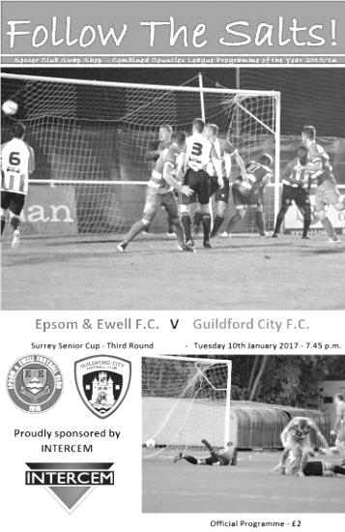
The conclusion of this Surrey Senior Cup match at High Road was a case of all hands to the pump for the visitors as they tried and ultimately succeeded in repelling our search for an equaliser. However, if we had shown the same tempo and desire in the previous hour we would surely not have been two goals down in the first place, leaving us with a deficit to retrieve for the third consecutive match.

There were a few changes at the back after our narrow win over Spelthorne Sports. Craig Hastings came in for the injured Charlie Clark-Gleave, while Captain Dan Dean returned to the starting line up at the expense of James Taylor who was on the bench. Finally, Ali Turpie went between the posts with Michael Eacott watching this one from the bench and quite possibly hoping for a run out in the middle of the park, following his 40 yard free kick strike for his Sunday side last weekend!

Up front we were unchanged and we started brightly. Jordan Gallagher cut in and struck a powerful shot just over the bar from 20 yards and Matt Tanton had space to send a low drive just beyond the far post. In the 18th minute we had arguably our best opportunity of the match as Rob Hendry won the ball of one defender, nicked the ball past another and cut in on goal from the right wing. However, his angle was narrow and instead of rolling the ball across goal to one of three waiting players, he drove at goal and sent his shot just over the bar.

The visitors were creating little at this point except for a couple of set pieces where they were able to get their heads to the ball first but without causing Turpie any extra work. Hendry found Gallagher but from close range Luke Badiali in the visitors goal was the stronger of the two in the challenge and the danger was cleared. Further pressure ensued and in the 29th minute a poor clearance by a defender was collected by Gallagher some twenty yards out. He found Matt Ferdinando who beat one man but from just 12 yards he sent his shot a couple of feet beyond the top corner of the Guildford net.

It was looking as though it was just a matter of time before we would take the lead, but the game changed in the 36th minute when Kiye Martin scored with a curling strike from the edge of the area. It was a good shot, although questions needed to be asked

about how he could have so much room in such a dangerous position. As we have seen quite a bit recently, our confidence was knocked after the goal and we found it difficult to create anything else before half time with exception of a Reisse Griffin free kick that Dean met at the far post but his headed contact just sent the ball up in the air and our chance was then ended by a clumsy foul from Gallagher.

The second half started with a clear intent from the visitors. They were going to take a lot of time over everything and try to frustrate us for as long as the referee would allow it, which unfortunately was quite a while. We won a free kick on the edge of the area for a foul on Hendry, at which point Greg Haydon kicked the ball some fifty yards away but even that required an appeal from our players before the yellow card was shown. Unfortunately the free kick from Ferdinando was wasted as the strike on goal hit our own player, Griffin and went out for a goal kick!

We started to lose a bit of composure at this stage and picked up three yellow cards for fouls in quick succession. Things then got worse in the 66th minute when Guildford doubled their lead with a good goal. A pinpoint and arguably undefendable left wing cross from Alex Rose way out on the left touchline was perfect for Mario Embalo to head the ball in from close range and we were in serious trouble.

Changes were made and we started to press for a goal. Hendry saw his low shot well blocked by Badiali with the loose ball cleared, but shortly after this in the 81st minute he scored with a low drive from outside the area; the ball squirming past Badiali into the net. We continued to press and substitute Daryl Cooper-Smith found his close range shot blocked by a defender before Matt Farrell also had the same result from ten yards after Hendry had put him through. Right at the end Cooper-Smith tried his luck from 30 yards and I can confirm that the shot was on target but was quickly deflected for a corner by another defensive block. From the deep corner Griffin was spare at the far post but instead of heading back across goal he went for goal and his header dribbled wide of the post. Just over five minutes of injury time was played, of which the general consensus was that it was not long enough, but we were unable to score an equaliser to force a penalty shoot out.

Although the Surrey Senior Cup may not hold a particularly high priority at the start of the season, remaining in any cup competition in the New Year is a bonus and with the opportunity of a Quarter-Final place it was a pity that we fell away so badly against a hard working but limited Guildford team, especially after our fine performance against Chipstead in the previous round. We struggled against their physical presence at times and will have to solve that particular issue very quickly as they return here next Tuesday for a League match. We can play a lot better than this and it is equally frustrating for players, Management and supporters that we are not winning many matches like this right now.

Epsom and Ewell: Ali Turpie, Adam Heagney, Matt Tanton, Craig Hastings,
Dan Dean (c) Savvas 'Agi' Panayiotou, Jordan Gallagher, Matt Farrell, Rob Hendry, Matt Ferdinando, Reisse Griffin
Subs: Daryl Cooper-Smith for Gallagher (61), Jason Nwachukwu for Ferdinando (70)

Guildford City – History
The first club in the town was amateur side Guildford FC, formed in 1877, and known as the “Pinks”. They played home matches at the Woodbridge Road Sports Ground. A successful start led to a number of people mooting a new professional club and by the end of 1920 a professional side was formed, being they were accepted into the Southern League May 1921, the equivalent of today’s Conference League.

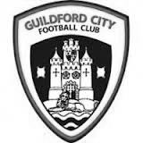
1927 saw the coming of Guildford as a Diocese and with it the building of a Cathedral. It was believed that Guildford would become a city so the Club changed its name and the “City” was born. At this time they also changed the colours to red and white stripes.

1927 saw Guildford become a Diocese and, coupled with the planned cathedral, it was believed that Guildford would become a city so the Club was renamed Guildford City. Although they had little early success in the League, the FA Cup bought a taste of glory in 1928-29 when, having battled through the qualifying rounds, they beat Queens Park Rangers 4-2 in the First Round Proper in front of a crowd of nearly 8,000. In the next round they were at home to Bournemouth but a similar crowd saw the visitors romp home 5-1.

In 1928-29 City were drawn at home to Queen’s Park Rangers in the FA Cup First Round proper and won 4-2 in front of almost 8,000 spectators. Despite excellent gates and the highest League finish to date the Club was facing a financial crisis at the end of the season – this was to be a recurrent theme throughout the Club’s history. At the start of the 1936/37 season the Club made the massive decision to turn full-time professional, appointing Haydn Green as manager. That season they finished fourth but next season things got even better.

1937/38 saw victory over Reading in the FA Cup but in the League they won 22 of their 34 games to finish as Southern League Champions for the first time. That feat was nearly repeated the following year, with City finishing runners-up to Colchester United by 1 point, scoring 126 goals in the process. Indeed the League game at home to Colchester on Easter Monday saw City win 3-1 in front of the highest crowd ever for a League game at Joseph’s Road 9,443. Earlier that season City had attracted an even bigger crowd to Joseph’s Road for an FA Cup 1st Round Replay against local rivals Aldershot. 9,932 saw City lose a nail-biting game 4-3.

This successful period was brought to a premature conclusion by the outbreak of the Second World War. The ground had been used by the Army during the War and it wasn’t until 1946/47 that City re-entered the Southern League – this time as a part-time club. They finished runners-up, this time to Gillingham but there followed 3 seasons of mediocrity. In 1950/51 the team finished 3rd in the League and reached the final of the Southern League Cup for the first time, losing to Merthyr Tydfil despite winning the first leg.

The 1951/52 season saw the longest trip ever undertaken by the City when they were drawn away to Gateshead in the 2nd Round of the FA Cup. An estimated 5,000 supporters made the overnight trip to the North East of England in December (there were no motorways in those days, and no heaters on coaches either!). A 15,000 crowd saw City dominate the game but lose 2-0. In debt again, City sold Jimmy Langley to Leeds for £2,000 – who eventually joined Fulham and earned three England international caps.

Archie Macaulay was brought in as player-manager in 1953 and he started building a side that would win the title in 1955/56. However, he left before the end of the season leaving Bill Thompson to take over and lead the side to the championship. In 1958/59 the League expanded and was regionalised. City were in the South Eastern zone and could only finish 15th out of 17.

For 1959 the League was revised again, this time to a Premier and First Division. City’s miserable time the year before meant they started in the lower division. Albert Tennant, who had been a coach at Chelsea,

took charge and he led City to promotion. After a season of consolidation, the next four seasons saw finishes of 3rd, 4th, 4th and 2nd: on the last occasion only 2 points behind champions Weymouth. In the

1962/63 season they also lifted the Southern League Cup for the first time, beating Nuneaton Borough 2-1 on aggregate over two legs.

Despite this success by the summer of 1965 it seemed that finance was again a major problem at the Club. A strict budget left the club short of players, resulting in a disappointing 16th place finish, although they did manage to reach the final of the Southern League Cup again. They went on better the next year, winning the Southern League Cup with a 2-1 aggregate success over Barnet.

1967/68 saw a notable FA Cup run. Drawn away to Brentford the City were leading 2-1 when the match was abandoned during the second half because of snow. A second trip to Griffin Park ended with a 2-2 draw and meant a replay at Joseph’s Road in front of 7,500 fans who roared City to a famous 2-1 victory. Goalkeeper Peter Vasper was sold to Norwich City for £5000 and it was thought that this money and the money from the Cup games might ease the Club’s financial problems but they were worse than many had realised. The following season saw the end of Albert Tennant’s nine year reign and the Club was relegated.

In 1969/70 Joseph’s Road was sold to signal the beginning of the end for the Club. The following year they reached the second round of the FA Cup but the inevitable was only being delayed and although in 1972/73 the Club again reached the first round of the FA Cup (a visit to Watford ended with a 4-2 defeat), they could only finish 18th in the League. Crowds of 4,000 were needed to break even but barely a quarter of that was achieved at most games.

The Surrey Advertiser advised a new board of directors in place for 1973/74 with Bill Bellerby elected President (recently elected as Patron of the new club) and Club stalwart Darby Watts as player manager. Despite the best efforts of Mr Bellerby and the long standing Chairman of the Supporters’ Club John Daborn, it was soon announced that the Club was to merge with Dorking and play at Meadowbank. The final game at Joseph’s Road was played on 12th February 1974 when the City beat Folkestone 2-0 in front of 625 fans. After 53 years senior football at Joseph’s Road had come to an end.

In 1996 Bill Bellerby, then Mayor of Guildford, enquired as to whether Burpham FC would be prepared to move to the Spectrum Leisure Centre and represent Guildford. Spectrum provided a venue which had the potential for development into senior football and already had floodlighting. AFC Guildford played in the Surrey Premier League, which eventually became Division One of the Combined Counties League. In 2003/04 AFC Guildford were crowned champions of Division One and gained their first ever major honour.

Promotion was obtained into the Combined Counties Premier Division, ground-sharing with Cranleigh FC while Spectrum was upgraded to an acceptable standard. In early November 2004, AFC Guildford returned to their home ground near to the town centre.

After a 12 month period as Guildford United, the club was re-named the historically significant ‘Guildford City’, after an absence of thirty years. 2007-2008 saw City claim a runner up finish in the Combined Counties Premier League, under the management of Scott Steele and Lloyd Wye. Then saw a period of struggle which was only alleviated by the inspirational appointment of Kevin Rayner, and his assistant Roly Martin, who took charge in spring 2009.

Their first full season at City saw a much improved seventh place finish in 2009-10. The following year saw a good run in the FA Vase, an incredible FA Cup victory at Ryman Premier Tonbridge Angels, but also the Combined Counties Premier Division Championship. A second Combined Counties Championship was gained in 2012, resulting in an emotional return to the Southern League after a gap of 38 years.

Change was on the way after a creditable ninth place finish in the Central division. At the conclusion of 2012-13 Rayner departed for a new chapter in his career. However in November 2013 he returned to the Spectrum to lead an ultimately unsuccessful battle against relegation from the Southern League.

After a poor start to the 2014-15 Combined Counties League season, Kevin Rayner departed in November to be replaced by local coach Donovan Chislett who ultimately saved the club from relegation in an exciting climax to the season. Donovan himself departed in September 2015 to be replaced by former Godalming Town manager Dean Thomas but he was replaced by Steve Dormer.

Player Sponsorship
Here is the current list for the 2016/17 season showing all of our players and Management that are available for sponsorship.

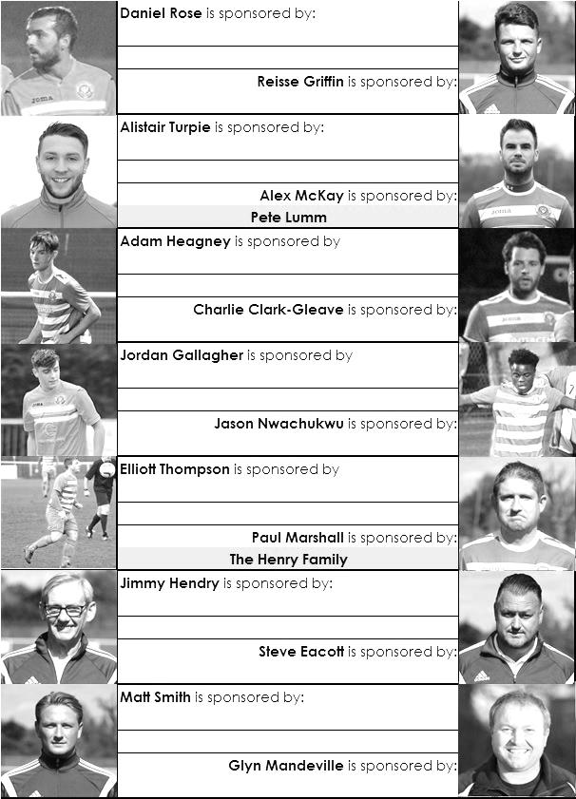

Sponsorship costs just £40 and it is easy to do. Just select a player who has not been previously sponsored and let a Committee Member know that you would like to sponsor them. Beware though. Until we have received the money it is possible for someone to jump in front of you, so don’t delay, sponsor today!
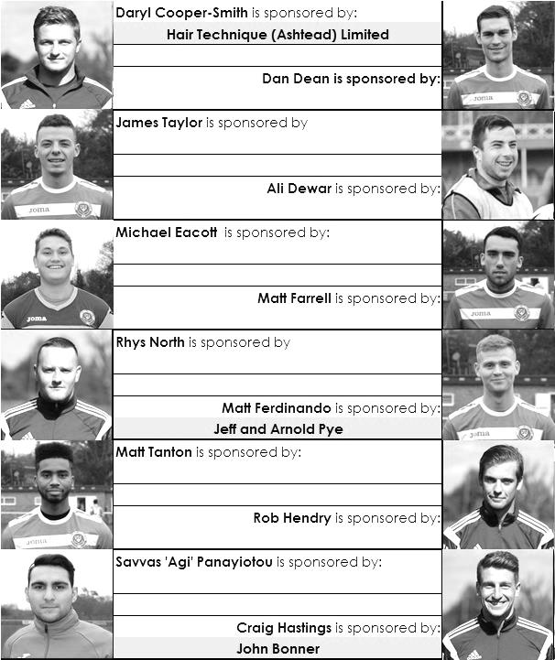

Centre page for results

Centre page for results

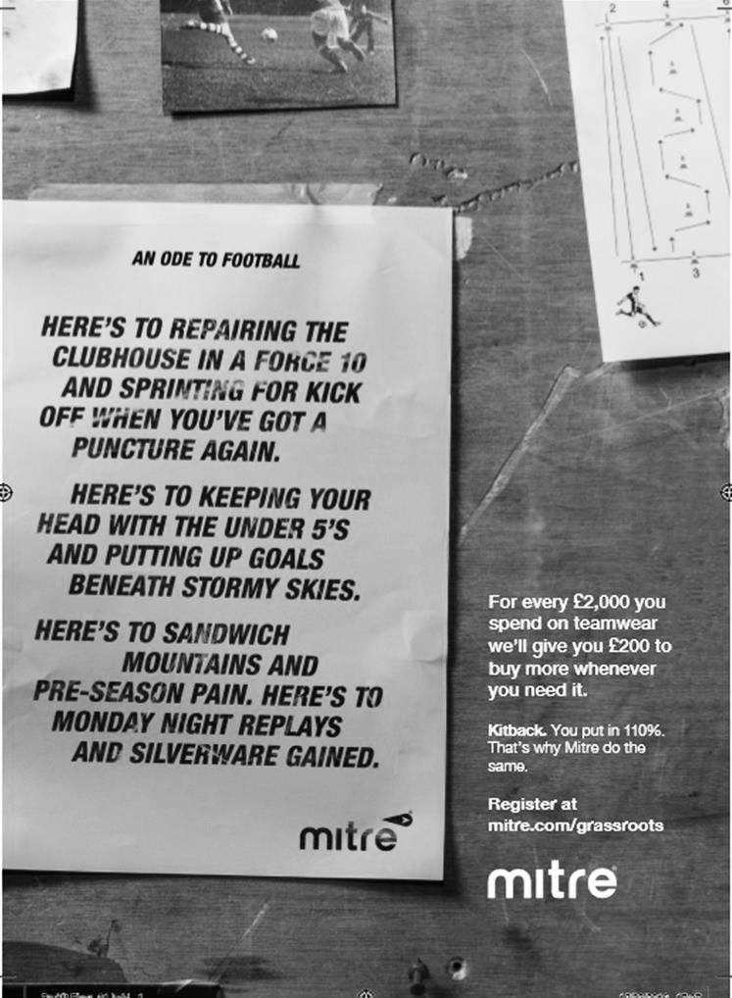

Surrey Senior Cup
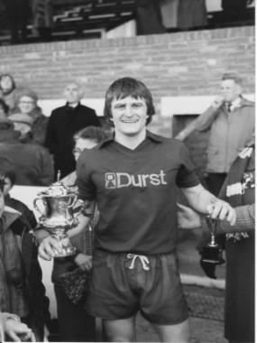
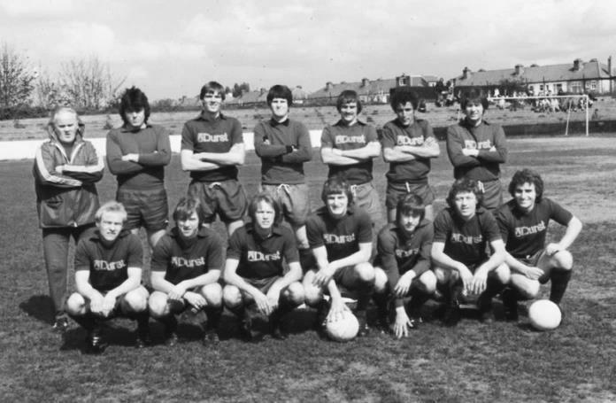
Second Round
Met Police | 0-0 | Kingstonian
Match played at Met Police F.C. – Kingstonian won 7-6 on penalties
Ashford Town (Mx) | 0-1 | Knaphill
Woking | 4-0 | Walton Casuals
Whyteleafe | 5-1 | Colliers Wood United
Guildford City | 3-3 | Horley Town
Guildford City won 3-2 on penalties
Egham Town | 3-0 | Corinthian Casuals
Godalming Town | 0-1 | Merstham
Molesey | 0-1 | Leatherhead
Raynes Park Vale | 1-1 | Sutton United
Raynes Park Vale won 4-3 on penalties
Sutton Common Rovers | 5-1 | Camberley Town
Dorking Wanderers | 2-1 | South Park
Badshot Lea | 1-0 | Farnham Town
Walton & Hersham | 3-0 | Croydon
Carshalton Athletic | 0-2 | Tooting & Mitcham United
Chertsey Town | 2-1 | Abbey Rangers
Epsom & Ewell | 3-0 | Chipstead
Third Round
Whyteleafe | 24/1 | Egham Town
Badshot Lea | 0-2 | Raynes Park Vale
Epsom & Ewell | 1-2 | Guildford City
Dorking Wanderers | 24/1 | Sutton Common Rovers
Chertsey Town | 1-0 | Kingstonian
Woking | 2-0 | Leatherhead
Merstham | 5-1 | Walton & Hersham
Tooting & Mitcham United | 24/1 | Knaphill

EL Records Premier Challenge Cup
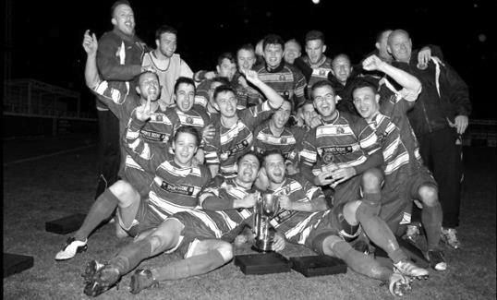
Second Round
Hanworth Villa | 2-4+ | Epsom and Ewell
AFC Hayes | 3-4 | Balham
Epsom Athletic | 1-5 | Windsor
Sutton Common Rovers | 2-1 | Bedfont Sports
Raynes Park Vale | 2-0 | Colliers Wood United
Frimley Green | 1-2 | Banstead Athletic
Westfield | 8-4+ | Redhill
Staines Lammas | 0-1 | Farnham Town
Worcester Park | 8-1 | Cove
Badshot Lea | 0-5 | Guildford City
Chertsey Town | 1-2 | Camberley Town
Cobham | 1-3 | Chessington & Hook United
Hartley Wintney | 4-0 | AC London
Horley Town | 2-2+ 5-4p | Sheerwater
Walton & Hersham | 5-1 | Eversley & California
Ash United | 2-0 | Farleigh Rovers
Third Round
Banstead Athletic | 4-4+ 3-4p | Westfield
Sutton Common Rovers | 19/12 | Walton & Hersham
Farnham Town | 0-4 | Camberley Town
Ash United | 0-2 | Windsor
Raynes Park Vale | 2-1 | Hartley Wintney
Guildford City | 2-1 | Balham
Horley Town | 2-0 | Chessington & Hook United
Worcester Park | 3-6 | Epsom & Ewell
Quarter Finals
Windsor | 24/1 | Horley Town
Guildford City | 25/1 | Raynes Park Vale
Westfield | 17/1 | Camberley Town
Walton & Hersham | 31/1 | Epsom & Ewell

First Eleven Appearances 2016/17 - (max 35)
Name | Debut | 2016/17 |  |  |  | Career Totals
 |  | App | Sub | Total | Goals | App | Sub | Total | Goals
CLARK-GLEAVE Charlie | 23/08/2016 | 3 | 2 | 5 | 0 | 3 | 2 | 5 | 0
COOPER-SMITH Daryl | 03/01/2015 | 25 | 3 | 28 | 25 | 55 | 11 | 66 | 45
DEAN Dan | 02/08/2014 | 25 | 2 | 27 | 0 | 93 | 6 | 99 | 2
DEWAR Ali | 29/10/2011 | 0 | 1 | 1 | 0 | 55 | 36 | 91 | 10
EACOTT Michael | 02/08/2014 | 27 | 0 | 27 | 0 | 112 | 1 | 113 | 0
FARRELL Matt | 02/08/2014 | 33 | 0 | 33 | 14 | 119 | 4 | 123 | 32
FERDINANDO Matt | 20/09/2014 | 18 | 6 | 24 | 3 | 71 | 12 | 83 | 17
GALLAGHER Jordan | 07/08/2016 | 21 | 12 | 33 | 9 | 21 | 12 | 33 | 9
GRIFFIN Reisse | 08/08/2015 | 25 | 6 | 31 | 2 | 53 | 12 | 65 | 4
HASTINGS Craig | 08/08/2015 | 23 | 6 | 29 | 1 | 60 | 10 | 70 | 1
HEAGNEY Adam | 16/08/2016 | 23 | 4 | 27 | 0 | 23 | 4 | 27 | 0
HENDRY Rob | 08/08/2015 | 25 | 7 | 32 | 7 | 55 | 18 | 73 | 19
MCKAY Alex | 20/12/2008 | 16 | 3 | 19 | 3 | 124 | 33 | 157 | 11
NEALE Tom* | 13/10/2015 | 6 | 5 | 11 | 7 | 22 | 24 | 46 | 17
NORTH Rhys* | 16/08/2015 | 2 | 2 | 4 | 0 | 19 | 9 | 28 | 1
NWACHUKWU Jason | 01/10/2016 | 5 | 10 | 15 | 0 | 5 | 10 | 15 | 0
PANAYIOTOU Savvas | 03/01/2015 | 27 | 4 | 31 | 4 | 59 | 12 | 71 | 11
PRICE Matt* | 23/08/2016 | 2 | 0 | 2 | 1 | 2 | 0 | 2 | 1
ROBINSON Sam* | 22/10/2011 | 7 | 1 | 8 | 1 | 61 | 6 | 67 | 14
ROSE Daniel | 25/10/2016 | 2 | 5 | 7 | 0 | 2 | 5 | 7 | 0
SALEH Mennar* | 24/09/2016 | 0 | 2 | 2 | 0 | 0 | 2 | 2 | 0
SMITH Matt | 08/08/2009 | 0 | 2 | 2 | 1 | 91 | 45 | 136 | 11
TANTON Matt | 02/08/2014 | 30 | 1 | 31 | 1 | 87 | 5 | 92 | 3
TAYLOR James | 26/08/2013 | 28 | 3 | 31 | 2 | 114 | 15 | 129 | 8
THOMPSON Elliott | 09/02/2016 | 3 | 0 | 3 | 1 | 7 | 9 | 16 | 1
TURPIE Alistair | 31/03/2016 | 8 | 1 | 9 | 0 | 10 | 1 | 11 | 0
WATRET Jack* | 02/08/2016 | 1 | 0 | 1 | 0 | 1 | 0 | 1 | 0
* player has left the club

Combined Counties League Premier Division Opponents
All-time Records
incl Saturday 14th  January | P | W | D | L | F | A | PPG | GD | Best  Win | Worst  Loss
Bedfont & Feltham | 1 | 1 | 0 | 0 | 9 | 2 | 3.00 | +7 | 9-2 | X
Spelthorne Sports* | 6 | 5 | 1 | 0 | 15 | 6 | 2.67 | +10 | 6-2 | X
Sutton Common Rovers | 12 | 9 | 2 | 1 | 30 | 14 | 2.42 | +16 | 4-0 | 1-4
Horley Town | 29 | 20 | 5 | 4 | 65 | 30 | 2.24 | +35 | 6-0 | 1-3
Colliers Wood United | 22 | 14 | 2 | 6 | 45 | 33 | 2.00 | +12 | 4-0 | 0-5
Bedfont Sports | 10 | 6 | 2 | 2 | 18 | 11 | 2.00 | +7 | 5-1 | 0-4
Abbey Rangers | 3 | 2 | 0 | 1 | 10 | 4 | 2.00 | +6 | 7-1 | 2-3
Westfield | 19 | 11 | 3 | 5 | 40 | 31 | 1.89 | +9 | 6-1 | 0-4
Farnham Town | 14 | 8 | 2 | 4 | 25 | 23 | 1.86 | +2 | 3-1 | 1-4
Knaphill | 7 | 4 | 1 | 2 | 15 | 8 | 1.86 | +7 | 4-0 | 1-2
Guildford City | 18 | 10 | 1 | 7 | 35 | 24 | 1.72 | +11 | 5-1 | 1-5
Badshot Lea | 18 | 8 | 3 | 7 | 35 | 34 | 1.67 | +1 | 4-1 | 0-4
Hanworth Villa | 17 | 8 | 4 | 5 | 38 | 27 | 1.65 | +11 | 5-0 | 1-4
Walton & Hersham | 50 | 24 | 10 | 16 | 101 | 97 | 1.64 | +4 | 6-0 | 0-8
Raynes Park Vale | 28 | 13 | 7 | 8 | 59 | 38 | 1.64 | +21 | 6-1 | 0-2
Camberley Town* | 89 | 38 | 22 | 28 | 158 | 123 | 1.52 | +35 | 9-1 | 0-4
Hartley Wintney | 11 | 4 | 3 | 4 | 26 | 20 | 1.36 | +6 | 5-0 | 2-4
Windsor | 49 | 19 | 12 | 18 | 90 | 90 | 1.41 | 0 | 4-0 | 0-6
Chertsey Town | 48 | 18 | 5 | 25 | 72 | 87 | 1.23 | -15 | 3-0 | 0-7
AFC Hayes | 9 | 2 | 3 | 4 | 18 | 17 | 1.00 | +1 | 7-0 | 0-3
North Greenford United | 11 | 3 | 2 | 6 | 15 | 20 | 1.00 | -5 | 3-0 | 1-4
CB Hounslow United | 2 | 0 | 0 | 2 | 2 | 7 | 0.00 | -5 | X | 1-5
* includes one abandoned match v Camberley and one loss on penalties v Spelthorne

Match and Ball Sponsorships – 2016/17
Opponent | Date | Match Sponsor | Ball Sponsor
Gravesham Borough | 07/08/16 | Club President - Stella Lamont
Gravesham Borough | 07/08/16 | Relocation Committee Member - Mike Lovett
CB Hounslow United | 16/08/16 | EEFC Management Committee
Abbey Rangers | 23/08/16 | Steve & Geoff Dyke
Horley Town (11.30am) | 29/08/16 | In Memory of Chris Henry
Abbey Rangers (LC) | 06/09/16 | Paul Merritt
Camberley Town | 10/09/16 | Building Shop Ltd
Knaphill | 24/09/16 | EEFC Holding Company Director – Pete Lumm
Bridon Ropes (FAV) | 22/10/16 | George and Joseph Saunders
Sutton Common Rovers | 08/11/15 | Alex McKay Senior
Abbey Rangers (FAV) | 13/11/16 | EEFC Holding Company Director – Dave Ellins
Windsor | 15/11/16 | In Memory of Wally Dyke
Bedfont Sports | 19/11/16 | John Bonner
AFC Hayes | 26/11/16 | Jack Jarman
Chipstead (SSC / DWT) | 06/12/16 | Trevor Stotten
Hanworth Villa | 13/12/16 | Roger and Carol Farrell
Chertsey Town | 17/12/16
Raynes Park Vale (11.30am) | 27/12/16 | In memory of Dave and Liz Marshall
Spelthorne Sports | 07/01/17 | Building Shop Ltd
Guildford City (SSC) | 10/01/17 | Super Six Winner – Rita Christian
Guildford City | 17/01/17
Bedfont & Feltham | 21/01/17 | Programme Editor - Richard Lambert
Badshot Lea | 04/02/17
Westfield | 18/02/17
Walton & Hersham | 04/03/17
Hartley Wintney | 18/03/17
Farnham Town | 25/03/17
Colliers Wood United (1pm) | 14/04/17 | Good Friday match – make a note!
North Greenford United | 22/04/17 | Club President - Stella Lamont
For League, League Cup and Surrey Senior Cup Matches:
Match sponsorship - £40.00 Match ball sponsorship - £25.00. Combined £55.00.
For F.A. Cup and F.A. Vase matches:
Match sponsorship - £50.00 Match ball sponsorship - £30.00. Combined £65.00.

Sponsorship includes: (x2 for match, x3 for match and ball)

Admission, programmes, hospitality and advertising and mascot for the day (if required).
If you are interested, just speak to a Committee Member, or drop me an email at: richard.c.lambert@gmail.com

We also thank our Kit Sponsors INTERCEM

Salts Super Six Predictor
The Salts Super Six Predictor is live again for today’s match and the tickets are on sale at today’s game to the left of the gate. The matches are to be played this Saturday.

The jackpot was won recently but is already increasing and is now up to £282.

The competition is easy to play! To win, you simply need to predict the results of six matches correctly from the three options, fill in the form and make sure it is back with our seller before the deadline on the ticket. The latest fixtures are shown below.

If you are a club regular, you just need to place your name on the sheet, although if you aren’t, then we’ll need a contact number from you too. We will announce any winners on the website within three working days, so don’t worry, we won’t miss you!

Please note that if there is more than one winner, the prize pot would be shared between the winners. All you need to do now is have a go, as many times as you like!

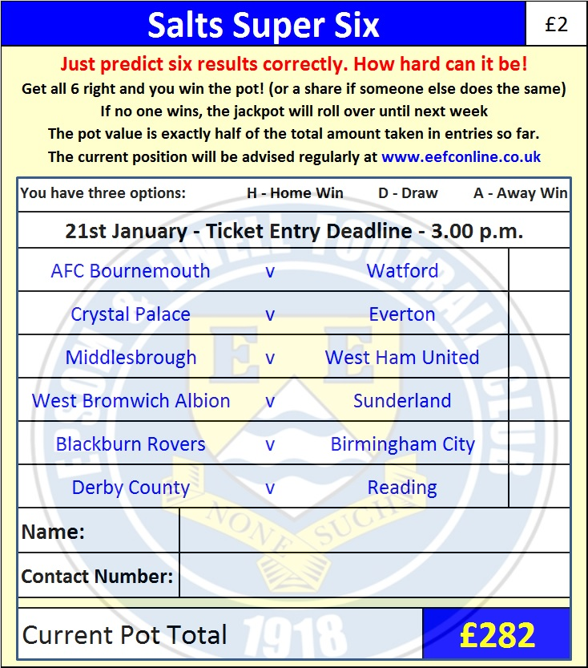

Good luck!

Combined Counties League – Premier Division
Tuesday, 17th January 2017 - Kick-off 7.45 p.m.

Epsom and Ewell  (Royal Blue & White hoops) | V |  | Guildford City  (Red and White)
Squad | NUMBERS |  | Squad
Michael Eacott |  |  | Luke Badiali
Adam Heagney |  |  | Matt Petts
Matt Tanton |  |  | Alex Rose
James Taylor |  |  | Darryl Siaw
Craig Hastings |  |  | Callum Wilson
© Dan Dean |  |  | Dan Akinwande
Jordan Gallagher |  |  | Adriano Moraes
Matt Farrell |  |  | Kiye Martin
Rob Hendry |  |  | Shawn Lyle
Savvas ‘Agi’ Panayiotou |  |  | Leon Lalor-Dell
Matt Ferdinando |  |  | Cameron Karembo
Jason Nwachukwu |  |  | Jamel Johnson
Reisse Griffin |  |  | Greg Haydon
Daryl Cooper-Smith |  |  | Lee Hall
Alex McKay |  |  | Mario Embalo
Daniel Rose |  |  | Suleiman Djalo
Alistair Turpie |  |  | Alpha Cauwenbergh
Charlie Clark-Gleave |  |  | Tom Booth
Matt Smith |  |  | Tom Bingham
Glyn Mandeville | MANAGER |  | Steve Dormer
Matt Smith | ASSISTANT |  | Chris Balchin
Steve Eacott / Alex McKay /  Jimmy Hendry | COACHES / PHYSIO
REFEREE: O.Davies
ASSISTANTS: R.van Niekerk, K.Corrick

OUR NEXT VISITORS TO HIGH ROAD
Bedfont & Feltham
Combined Counties League – Premier Division
Saturday 21st January 2017 – 3.00 p.m.

